**Contributors: Kaitlyn Younger, Dominic Polcyn, Ayush Pant, Thien Tran**

1. Description of solution:

* Description:
  + The project involves designing and implementing a glove that can detect how close the person is to their clothes, detect colors, and match them with other suitable ones. The primary objective is to be able to match clothing to create different outfits. It is easy for visually impaired people to wear jeans and a top, but there are many instances where they have to branch out and need to be able to match, for example, needing to wear slacks for a business meeting and accidentally choosing brown pants and a black blazer. This product is most helpful for those with an extensive collection of clothes in their closet because it will allow them to flip through clothes quickly and tell the color and how to match it.
* Requirements:
  + Functional requirements - must be wearable, able to tell shades of colors, needs to detect how close you are to desired fabric, say to the user, in different phrases, what color the clothing is and what would match with it
  + Non-functional requirements - lightweight, user friendly, not too loud/ abrasive, comfortable to wear, relatively fashionable, should allow the user to still feel material, needs to maintain mobility
  + Constraints - budget, time limit, programming ability(no AI), no ability to tell what fabric the clothing is, durability and maintenance, sensor accuracy, weight of battery and components.
* Sensors (input):
  + RGB sensor - detects the color of the clothing the user is trying to scan
  + Ultrasonic sensor - detects how close or far the product is from the clothing to know when the product should or should not actively running
  + Button - power button that runs the programs when pressed and then stops when pressed again.
* Outputs:
  + Vibrator motor - the purpose is to give the user a subtle buzz or vibration when the user is close enough to the clothing and the sensors are scanning.
  + Speaker - will tell the user what color the clothing is with different phrases and say to the user the possible color matching options that go well together.

1. Refined sketch:

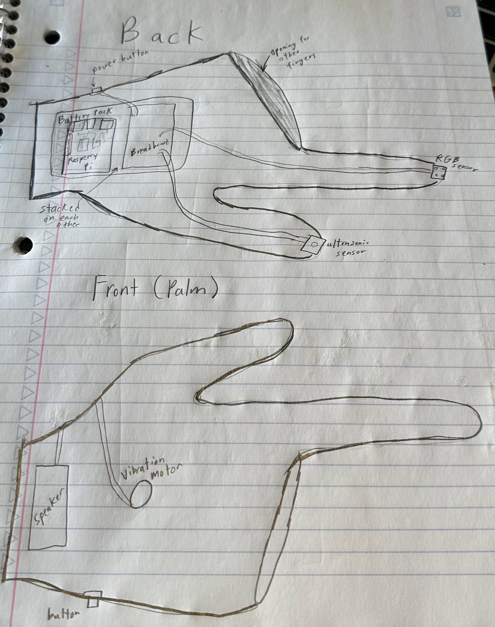

1. Use Cases:

* The wearer will don the glove using only their thumbs and index fingers, leaving the other fingers unrestricted. To approach a particular object, such as their clothing, they will use their thumb until the glove's speaker notifies them of reaching the appropriate distance by some signals.
* If the user is unable to approach the desired object, like their clothes or any item for color detection, the speaker will instruct them to come closer and repeat the object detection process.
* If the glove successfully detects and recognizes the user's clothes, they can use the index finger on the garment to allow the glove to continue detecting colors and providing information to the user. For instance, if the glove successfully recognizes your item, and if the color detected is red, it will inform you that the red color is present on your item.
* The user will be aware of the glove's color detection failure when it consistently prompts them to get closer. In such instances, the entire process will restart from the beginning, requiring the user to approach their clothes once again for the object detection phase.
* When the glove successfully detects the color, it will offer the user some brief suggestions on how they can combine the identified color with other items to create a stylish outfit. As an illustration, if the glove detects that your shirt is red, it will recommend coordinating colors such as black, white, navy blue, gray, or simply pairing it with jeans.
* The glove will incorporate various sensors, including RGB and ultrasonic sensors, along with a vibration mechanism, a button, and a portable battery. While its weight is substantial, it is not excessively heavy, ensuring practicality and comfort for the user.
* Primarily designed for vision-impaired users, the glove aims to provide convenience. The recent alteration to a 2-finger design has been implemented to enhance user adaptability, making it significantly easier for them to acclimate to and utilize the product effectively.